Federal State Autonomous Educational Institution for Higher Education «NATIONAL RESEARCH UNIVERSITY
«HIGHER SCHOOL OF ECONOMICS»

Faculty «Saint Petersburg School of Economics and Management»
Department of Management

Gavrilova Veronika Sergeevna
Murchich Natalia Nikolaevna

THE IMPACT OF CLOUD COMPUTING ADOPTION ON FIRM PERFORMANCE:
MODERATING ROLE OF IT HUMAN CAPITAL
BACHELOR THESIS
EDUCATIONAL PROGRAMME
«International Business and Management Studies»

Student’s group number № 206

Adviser
Senior lecturer

Daviy Anna Olegovna

Saint Petersburg
2024

Abstract
Within the emerging Industry 4.0, Russian enterprises are facing an increased demand to adopt digital technologies. At the same time, cloud computing services are beginning to draw greater attention. Although some researchers have discovered a positive relationship between the integration of new advanced technologies and firm performance, recent evidence suggests that the effect of such technologies on financial performance is still ambiguous and remains a mainly under-examined topic. In addition, prior studies frequently managed to investigate the influence of external factors on the relationship under consideration. However, the moderating role of IT human capital on the association between technology adoption and SME performance has been scantily explored. Thus, the study aims at solving a problem in the estimation of the empirical relationship between cloud computing adoption and Russian SME performance with a focus on the verification of the moderating role of IT human capital. The responses obtained from SMEs through a questionnaire were evaluated using the multiplicative interaction model. The regression analysis revealed a positive statistically significant impact of the cloud technology adoption on companies’ cost savings, accounting returns, and market shares. Meanwhile, contrary to expectations, with an increase in the level of IT knowledge and skills of employees, the impact of cloud-based services on cost savings and market share of SMEs becomes weaker. The moderating effect on the relationship between cloud technologies and accounting returns was not supported. These findings extend the existing theoretical knowledge by exploring the synergistic effect of physical and human capital resources on the financial firm performance. They also provide valuable insights for SMEs on how to allocate resources to enhance their performance. Finally, the research area can be developed by investigating the firm performance outcome with other moderating variables or different digital technologies scenarios.
Keywords: SME digitalization, Cloud Computing, Financial performance, IT human capital, Resource-based view

Table of Contents
Introduction 5
Literature Review 9
Technology Adoption and Performance 9
Prior Research in Cloud Computing Adoption by SMEs 10
Conceptual Model Building 11
Hypotheses Development 13
Methodology 16
Research Design 16
Sampling and Data Collection 17
Manual Robustness Check 18
Descriptive Statistics 18
Measurement of the Variables 20
Methods of Analysis 22
Results 25
Discussion 30
Conclusion 34
Reference List 37
Appendices 41
Appendix 1 41
Appendix 2 42
Appendix 3 43
Appendix 4 44
Appendix 5 46
Appendix 6 47
Appendix 7 48
Appendix 8 50
Appendix 9 51
Appendix 10 52
Appendix 11 54

Introduction
Background. The twenty-first century has seen a shift to Industry 4.0. (also called the Fourth Industrial Revolution). Many new technologies (e.g., Augmented Reality, Internet of Things, Big Data, Cloud Computing, etc.) have been widely used with the release of Industry 4.0 (Kagermann et al., 2013, as cited in Omurgonulsen et al., 2021). For the first time the concept “Industrie 4.0” appears in a high-tech plan, developed by the German government. The German project’s primary goal was to assist small and medium-sized enterprises (SMEs) in comprehending and utilising the technologies of the next digitalisation phase. While some firms view this stage as a great chance to improve their performance and gain market superiority, others face difficulties and pressure to keep up with the rapid technological changes.
It is widely known that there is the prevalence of diverse digital technologies. Although cloud computing as a concept has become more popular in recent times and quite a few studies have been conducted, the adoption and application level is still very low, particularly in developing countries (Godavarthi et al., 2023). This facilitates deeper exploration of such a technology with the focus on the consequences of its adoption. The National Institute of Standards and Technology provides a definition of the term cloud computing:
Cloud computing is a model for enabling ubiquitous, convenient, on-demand network access to a shared pool of configurable computing resources (e.g., networks, servers, storage, applications, and services) that can be rapidly provisioned and released with minimal management effort or service provider interaction. (NIST, 2011, p. 2)
In the scientific literature, various types of cloud computing technologies are explored and studied. Nonetheless, authors typically differentiate between the following three types: Software-as-a-Service (SaaS), Platform-as-a-Service (PaaS) and Infrastructure-as-a-Service (IaaS).
With Software as a Service, the customer accesses an application or tool created by an external provider through a web browser. The client merely needs to pay a membership fee, while the provider handles program updates and technical assistance. Under this delivery model, the customer cannot manage the infrastructure or manipulate applications according to the company's preferences (Mell & Grance, 2009). SaaS is currently the most common among businesses and includes services such as Microsoft Office 365, Gmail, Dropbox, Oracle CRM, SAP.
Using Platform as a Service, businesses can access database management systems, operating systems, and development and testing tools. In this case, the user has greater control over the apps that have been deployed and may modify the application-hosting environment's configuration parameters (Mell & Grance, 2009). Examples of Paas are Google App Engine, IBM Bluemix, Microsoft Azure, OpenShift.
A virtual server with a specific amount of processing power and memory is what the customer gets when they purchase Infrastructure as a Service. Although operating systems, storage, and installed apps are all under the consumer's control, they do not have any influence over the underlying cloud infrastructure (Mell & Grance, 2009). Company system administrators are the ones who use IaaS the most frequently. A few of the most popular IaaS services are Google Compute Engine, Cisco Metacloud, Amazon Web Services, and DigitalOcean.
Problem Statement. The need for SMEs to embrace new technologies has been emphasised in the literature multiple times. Various researchers have identified the ways how technology adoption can benefit the performance of SMEs. Firstly, SMEs that introduce information communication technologies are able to gain new opportunities, learn more about the market, and improve their product development process (Fu et al., 2014). Moreover, the scope of SMEs to some extent can be considered as a beneficial trait. Owner-Managers with a positive identification with digital technologies can build a digital identity consisting of future norms, standards and values which in turn can be easily shared with employees, because of the small size and flexibility of a SME (Bouncken & Barwinski, 2020). Likewise, Eller et al. (2020) attempted to investigate SME state of digitalization readiness and assess the impact of digitalization on SME performance. The study highlights the importance of using technologies such as data processing technologies, cloud computing services, mobile technologies and others, since they all have a positive impact on the financial performance of SMEs.
Despite a fringe of scholars finding a positive relationship between technology adoption and firm performance, the lag between SMEs and larger firms in the context of digitalization is still observed. “In general, the impact of digital technologies on productivity change is estimated to be stronger in larger than in smaller firms” (Nucci et al., 2023, p. 14). In the literature, this lag is explained by a number of obstacles that prevent companies from investing in new technologies. At the 4th International Conference on Industry 4.0 and Smart Manufacturing, the primary challenges were divided into four categories, namely, technical, organisational, technological and legal barriers (Telukdarie et al., 2023). Although researchers have already discussed the relationship between technology adoption and productivity improvements, the existence of certain barriers for SMEs makes it difficult to reach a consensus on whether smaller companies should spend their limited financial resources on adopting new technologies. This creates a research gap that we address.
The majority of earlier research on the connection between technological revolution and company performance omitted a number of internal and external factors that can play a moderating role in this relationship. Right now, the conversation is concentrated around such crucial factors as perceived usefulness, attitude towards using technology (Lal & Bharadwaj, 2020), top management commitment during initial stages of technology integration (Zamani, 2022), security of the system (Fu et al., 2014), etc. Not many scholars have paid attention to employees’ knowledge and experience with IT-related services, as well as having an overall understanding of how to work with modern technologies. However, it is important to understand that new technological advances are not highly valuable in an environment where there are few skilled personnel who can employ them (Becker, n.d.). This is supported by the idea of Talukder (2012) that “despite an organisational decision to adopt an innovation, its actual usage depends on how employees implement an innovation” (p. 52). This requires consideration of IT human capital (Josefek & Kauffman, 2011), which is expressed in the technical skills of the company’s employees, including technical knowledge and the capacity to use it effectively (Park et al., 2011). Hence, in this study we also address the gap in the research concerning the significance of an IT human capital as an essential factor that influences technology adoption and firm performance association. Thus, the study aims to solve a problem in the investigation of cloud computing adoption in SMEs by considering the verification of the influence of IT human capital as an external parameter on the discussed relationship.
Research Aim. Consequently, this study is intended to examine the empirical relationship between cloud computing services and SME performance with a focus on the moderating role of IT human capital, considering the context of Russian organisations. With this aim, the following research question is posed: To what extent does IT human capital moderate the relationship between cloud computing adoption and performance of Russian small and medium-sized enterprises (SMEs)?
In order to achieve the given aim, the study has constructed a research model based on resource-based view (RBV). This approach was used for investigating the impact of cloud computing adoption on SME performance, including moderating effect on it. Three firm performance indicators are identified, namely, cost savings, accounting returns, and market share. Data collection from the organisations was conducted through a structured questionnaire method using convenience and “snowball” sampling techniques. The proposed model was tested by regression analysis employing the multiplicative interaction model followed by a discussion of the obtained results.
Professional Significance. This research expands upon the body of previous literature regarding how technology adoption leads to increased indicators of firm performance. The study reached the findings regarding the main trends and features of the development and utilisation of digital technologies in the context of SMEs. The obtained results shed light on the mechanisms through which cloud computing can contribute to SME success. The mechanism disclosed in the research considers technology as a physical resource in conjunction with a non-physical – human capital. The empirically proven synergistic effect between cloud-based services and IT human capital will help Russian SMEs to effectively develop a portfolio of resources to achieve maximum benefits from the introduction of new technologies into the company. Hence, unlike similar studies in the domain of digitalization and firm performance, this one includes a moderating variable in the model. By examining the moderating role of IT human capital, we highlight that there is no need to have a workforce with strong IT skills and experience in order to maximise the potential advantages of cloud computing adoption for SMEs. All in all, this study assists SMEs in understanding the fundamental ideas behind the adoption of cloud computing and its potential benefits. Moreover, the results of this study can be perceived as a call to action for SMEs to embrace the digitalization era and become less hesitant regarding the investments into cloud computing services. Our results raise doubts about the strategic need of building up an organisation's internal IT knowledge base since successful technology integration may not require the possession of specialised IT knowledge and skills.
Delimitations of the Study. Out of all the technologies that have become widespread among businesses since the start of the new phase of digital transformation, this study solely focuses on cloud computing technologies, specifically on their three primary categories (IaaS, SaaS, PaaS). The human capital of companies in the context of the introduction of cloud computing was narrowed to IT human capital. This term refers to collective knowledge and skills related to utilisation of IT and possessed by individuals within the organisation. Moreover, the geographic scope covers Russian SMEs that were included by the federal tax service in the unified register of small and medium-sized businesses.
The remainder of the paper is organised as follows: The subsequent section reviews prior literature on the topic and defines the concepts of the study, resulting in the hypotheses development. In the Methodology section a description of the research design and the data obtained is presented. Next, we discuss the accomplished results of the statistical tests and, in the final section, we conclude the study along with a discussion of the theoretical contributions and managerial implications.

Literature Review

Technology Adoption and Performance
Recent studies show that a company’s ability to innovate and obtain a competitive advantage are frequently linked to its adoption of new technologies. Blichfeldt, H. and Faullant, R. (2021) stressed that “there is a need for continuous development and the adoption of digital technologies, as they support the overall product and service innovation capability of the company and its competitiveness” (p. 11). However, the authors did not discover a positive correlation between competitive advantage and the capacity to provide new services to the market. Ferreira et al. (2019) reached the same conclusions, stating that “the companies adopting new digital processes present a significantly higher number of innovations in products and/or services, with totals that demonstrate their greater innovation capability” (p. 6). A crucial comment made by the authors is that enterprises should implement digitalization strategies in line with the demands of the market in which they operate. Oduro et al. (2023) employed meta-analysis, integrating data from several contexts to investigate the variables in the relationship between digital technology and firm performance. The authors of this article contend that the advent of Industry 4.0 will inevitably result in the integration of intricate digital systems into corporate operations, enabling organisations to improve their overall business models, customer experiences, and operational procedures. Despite the risks and high costs associated with integrating digital technologies into a firm’s operations, the authors concluded that digital technologies can greatly increase a firm’s competitiveness. It was also emphasised that a competitive advantage can be created by management through the synchronisation of processes and the coordination of technological/digital resources and skills.
In contrast, Usai et al. (2021) obtained different results. Based on the open data from Eurostat, conducted econometric models brought to the conclusions that “traditional investments are by far more effective for innovation performance than digital technologies” (p. 332) and “digital technologies cannot replace the role of creativity, intuition, serendipity, and intellectual capital in the innovation process” (p. 332). The literature has not yet reached a general consensus on how technology adoption affects firm performance. Some researchers have managed to find a positive relationship between these two terms, while others found that in practice the effect is not that evident and may not have a significant positive impact on businesses’ activities.

Prior Research in Cloud Computing Adoption by SMEs
The study conducted by Wisetsri et al. (2022) was focused on exploring how to make the use of cloud computing suitable for a university organisation. Based on a critical evaluation of the practices of using this technology, authors stressed meaningful advantages of cloud computing, namely increased storage capacity, lower cost compared to traditional computing approaches, and flexibility. It was concluded that cloud-based services make the production of information easier and faster through the effective management of workloads. However, the authors also emphasised certain challenges caused by technology such as “security, legal difficulties, excess of data and cultural differences” (p. 2218). Despite some of the highlighted benefits of cloud computing in general, the researchers disagree on the impact of this technology on the companies’ performance.
Al-Shafari et al. (2023) assessed the drivers of integration of cloud computing within SMEs and further outcomes of the adoption regarding environmental, financial, and social performance of companies. The big takeaway from their study is that SMEs can benefit from cloud technology in many ways that will lead to more sustainable business operations. Cloud computing integration has a significant influence on the environmental and social performance of SMEs, together with which companies can achieve greater financial success. Based on radically different methods of inquiry, other studies have drawn the same conclusion about the strong impact of cloud computing adoption on the financial performance of firms (Gupta et al., 2013; Lal & Bharadwaj, 2020; Zheng et al., 2023).
For instance, cloud computing helps SMEs to “bring down their cost in a significant way” (Gupta et al., 2013, pp. 872-873). Together with this effect of the technology under consideration, the authors highlighted that perceived ease of use and the credibility of the service provider considerably influence the decision to adopt cloud services. However, the results of the study indicated that such enterprises do not find cloud computing reliable nor do they see its utility in case of sharing and collaboration with firms’ stakeholders. Another significant result was obtained in the research addressing the relationship between cloud-based services adoption and organisational performance. As indicators for the second variable, Lal & Bharadwaj (2020) considered Learning and Growth, Internal Business, and Customer Perspectives, in addition to Financial ones. It was determined that the cloud technology utilisation leads to an increase in labour productivity and employee satisfaction, enhanced customer relationship and overall business effectiveness. Moreover, Zheng et al. (2023) inferred a conclusion that companies which follow different strategic positioning use cloud computing in order to optimise various operational activities. Another study was linked to the examination of factors influencing the cloud computing adoption in the information technology (IT) sector, with a particular focus on supply chain processes as a dimension of company performance. There is “the strategic importance of moving towards the adoption of cloud computing services for supply chain management” (Hassan et al., 2022, pp. 6-7), being explained by the fact that the revealed results show a direct positive relationship between cloud computing adoption in supply chain management and firm performance.
To summarise, despite the fact that previous scholars coincide in existence with the impact of cloud computing adoption on different aspects of SME performance, there are various difficulties associated with the technology introduction. Researchers explored the relationship between two terms, concentrating on different angles of firm performance, hence, available results do not provide a comprehensive overview. Furthermore, the scope of all considered studies is limited to an in-depth study of SMEs in a specific context of particular countries (for instance, Malaysia and India), which, along with the contradictions, leads to a gap in the field of cloud computing adoption.

Conceptual Model Building
The study adopts a resource-based view (RBV) which assumes that a broad range of accumulated resources owned and controlled by the firm itself is the basis for the creation of competitive advantage (Barney, 1991). Wishing to further explore the direct link between technology and firm performance, a number of authors have applied this framework. For instance, Eller et al. (2020) examined the influence of IT, digital strategy, and employee skills on SME digitalization through the lens of RBV. Researchers constructed the relationship between these resources and the digitalization of companies which resulted in analysis of its impact on financial performance. Another study adopted this approach as a theoretical foundation to explain how IT-enabled supply chain capabilities can boost IT resources into higher value for a company (Wu et al., 2006). Among other things, there are several studies that have applied RBV in conjunction with other theories and approaches to explore more specific research questions (Rivard et al., 2006; Oduro et al., 2023).
According to RBV, a firm’s resources can be classified into physical capital, human capital and organisational capital, which, if strategically relevant, may become the main source of sustainable competitive advantage for sustained superior performance (Barney, 1991). The professor mentioned physical capital resources as the tangible assets of a company, including its equipment, geographic location, and access to raw materials. The technology itself is not a direct resource of the organisation. By technology adoption we mean not only the fact of its introduction, but also the process of its usage, otherwise it would be meaningless to measure the effect of this component on firm performance. In such a case, the technology forms the infrastructure utilised by the company, and thus becomes its physical resource.
In line with the preceding discussion of sustained competitive advantage, according to RBV, only those resources that possess 4 attributes have the potential for efficiency. They must be valuable, rare, imperfectly imitable, and “there cannot be strategically equivalent substitutes for this resource” (Barney, 1991, p. 6). It is important to mention that “physical resources confer little advantage to organisations because they can be bought and sold on the open market with ease” (Rothaermel, 2012 as cited in CIPD, 2017, p. 5). The same argument was espoused by Powell & Dent-Micallef (1997), as cited in Rivard et al. (2006), who revealed that IT resources themselves do not contribute to competitive advantage. This leads to the conclusion that technology adoption does not meet the specified condition in the aspect of rarity and imitation, as these barriers become quite low for other organisations. It is essential for a company to be able to properly allocate and deploy a bundle of its resources to achieve effective long-term results and as a consequence its superb performance.
There is a demand for a greater emphasis on human capital when discussing firm performance and competitive advantage (CIPD, 2017). Initially, “skills and knowledge are a form of capital” (Schultz, 1961, p. 1). Barney (1991) gave a more extended definition of this resource concept, which also includes the experience and intelligence of individual employees in a company. The combination of these elements provides a firm with a distinctive character from others (Bontis et al., 1999, as cited in Kuchsrčíková, 2011), which meets the RBV conditions for resources to become a source of competitive advantage. In other words, human capital can be referred to as the individual capacity based on KSAOs Model (knowledge, skills, abilities and other characteristics). This resource of the company is important not only at the individual level, but also at the level of the firm, which implies consideration of “the sum of human capital of all those individuals involved in an organisation, unit or team” (Haq, 2016, p. 262).
Notwithstanding the bulk of research has focused on the impact of one group of resources on firm performance, “the amalgamation of technology alongside human and social capital has long been overlooked in the literature” (CIPD, 2017). This confirms the necessity of studying the synergy of firm capital through the prism of RBV, where the impact of technology adoption (as a physical resource) on firm performance is considered taking into account the moderating role of human capital. The latter resource becomes an important participant of the explanatory mechanism, which finally enables the measurement of the synergistic effect on firm performance. As a consequence, a conceptual framework for the study is formed (Fig. 1), which provides an investigation of the moderating influence of human capital on the association between technology adoption and firm performance.
Figure 1
Theoretical Model
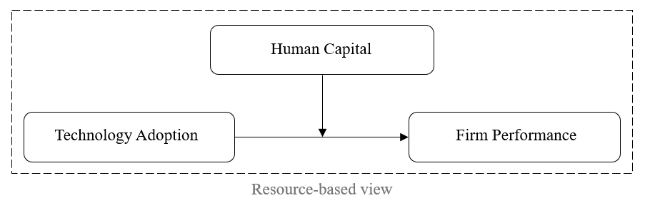

Hypotheses Development
To investigate the proposed relationship, the concepts are operationalised in order to ensure their validity and overall clarity of definition. The concept of technology adoption described above descends to a construct level that reflects cloud computing adoption. It is directly connected with the aim of the study which is focused on the specific digital technology. At the same time, firm performance is a multidimensional concept (Richard et al., 2009, as cited in Chen et al., 2022). In our study, the construct for it is the financial performance of the company as a constitutive component of the concept. Accordingly, we conceptualise cost savings, accounting returns and market share as three prominent attributes of SME financial performance. The theoretical arguments in favour of including each dimension are then discussed, enabling subsequent assessment.
Cost Savings. Previous studies have mentioned that cost savings is one of the major positive outcomes achieved by cloud computing adoption. It is determined that cloud services significantly influence SMEs in lowering costs (Gupta et al., 2013). Moreover, organisations benefit from this technology in case of minimisation of IT set-up and operational costs (Lal & Bharadwaj, 2020). From the other perspective, some researchers consider cost savings to be the driving force behind cloud computing adoption. Cost reduction along with other factors affect the integration of cloud-based services in SMEs, resulting in lower investment in in-house systems, purchasing and upgrading software applications costs (Al-Sharafi et al., 2023). Consistent with these findings, a positive association between the adoption of cloud computing and firms’ cost savings is predicted:
H1: Cloud computing has a positive impact on SMEs cost savings.
Accounting Returns. Accounting returns is a commonly used indicator of firm performance because it provides a clear measure of how effectively an organisation is utilising its resources to generate profits. In the context of this study the indicator can be valuable in order to evaluate future perspectives of a company. For instance, according to Zheng et al. (2023), the adoption of cloud-based services leads to higher accounting returns in the subsequent year. In other words, such a metric may help to assess the long-term impact of the technology adoption on financial performance of the firm. Thus, the hypothesis for further testing is derived:
H2: Cloud computing has a positive impact on SMEs accounting returns.
Market Share. Another widely used measure of a company's financial performance is market share, but within the scope of cloud computing research, the relationship between the technology and this indicator is debatable at first glance. However, a few studies emphasised that implementation of cloud-based services influence firm performance with regard to increase in market share. Cloud computing offers the development of new products and services and enables the creation of new market opportunities, e.g., new customer acquisition (Lal & Bharadwaj, 2020). Additionally, this technology facilitates streamlined business operations, enhancing supply chain efficiency and adapting to customer needs which results in increased market share of a company (Taufiq-Hail & Sarea, 2021, as cited in Hassan et al., 2022). Hence, in light of the above arguments, the following hypothesis is proposed:
H3: Cloud computing has a positive impact on SMEs market shares.
The concept of human capital itself is a multi-level one and includes many different branches (Ployhart et al., 2014). For example, professional development of employees plays not the least role in a company’s advancement, where “large increases in education and training have accompanied major advances in technological knowledge” (Becker, n.d.). In our study, the focus shifts to the exploration of IT human capital as a construct for the previously defined concept. As a resource of an organisation, it is rare, valuable and hard to imitate according to Barney (1991) and can be identified as a combination of employees’ professional knowledge, skills, competencies and experience in a particular IT domain. Chen et al. (2015) defined IT human capital as a set of human resources consisting of workers’ technical skills, interpersonal skills, and the position of team members in the face of technology. In addition to this, technical knowledge has to be considered as well as the skills and ability to implement, utilise and manage this knowledge and technology in general (Park et al., 2011). Therefore, to make the relationship between cloud computing use and SME performance more feasible, we include IT human capital as a moderator in this study. Hence, the following hypotheses are proposed:
H4: The positive effect of cloud computing on SMEs cost savings is stronger for SMEs with IT human capital.
H5: The positive effect of cloud computing on SMEs accounting returns is stronger for SMEs with IT human capital.
H6: The positive effect of cloud computing on SMEs market shares is stronger for SMEs with IT human capital.

Methodology
This study facilitates the proposition of a research model, based on the operationalization of three key concepts, i.e., ﻿technology adoption, firm performance, and human capital. Fig. 2 describes the model with the proposed hypotheses, which entail the relationship between technology under consideration and three indicators of SME performance, as well as the moderating effect on it.
Figure 2
Research Model
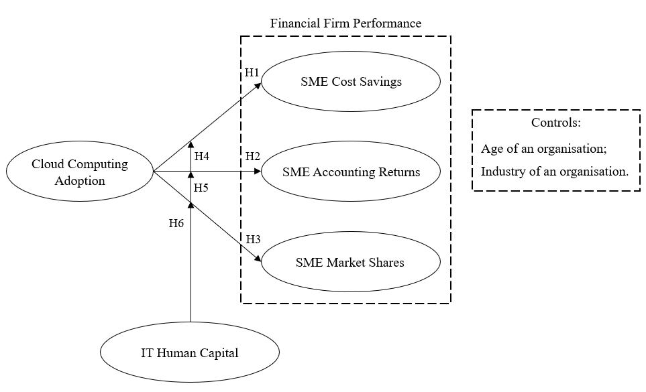

Research Design
The study follows the deductive approach since the research question is aimed at testing the hypotheses that emerge from RBV. In this case, the choice of quantitative methodology serves to accurately implement the research design and provides measures of reliability and validity. Given limited evidence regarding the research problem, i.e., the significance of the influence of IT human capital on the relationship between cloud computing adoption and SME performance, a correlational field study was adopted. This contributes to empirical investigation of the causal relationships between cloud computing adoption and SME performance, and the extent to which this relationship is moderated by employees’ technical knowledge.

Sampling and Data Collection
In order to achieve present study’s goals, a survey strategy was utilised. This method for conducting research implies the use of a structured questionnaire designed to elicit relevant data from respondents. The questionnaire was constructed independently, but with the adaptation of already existing scales emanated from previous literature on cloud computing implementation. These scales are explicitly appropriate for this research as they utilise specific items consistent with the identified clear theoretical constructs of the study, which reduces concerns on reliability. The questionnaire contained mostly close-ended questions with some open-ended ones for more in-depth analysis. Eventually, the survey was divided into four logical parts. In the first section respondents were asked to provide information on whether computing technologies are used by the company. The overall number of each type of cloud-based service and the level of its adoption were the subjects of several questions. The second part was designed to capture the details about respondents’ observed changes in the firm performance indicators of interest, namely cost savings, accounting returns and market shares. In the third section, respondents were asked to express their opinions regarding the presence of IT human capital components within the organisation. The questions in this section asked for information about general skills and knowledge in the IT field, as well as professional technical ones. The purpose of the survey’s final section was to gather general information concerning the organisation (such as age, industry, unique registration number (OGRN), etc.) and respondents themselves (e.g. position, gender, age).
The population of this research includes SMEs in Russia. According to the Unified Register of Small and Medium-sized Enterprises of the Federal Tax Service, as of March 10, 2024, there are 213,886 small and 18,737 medium-sized enterprises in the Russian Federation, which is approximately 233 thousand SMEs in total. Due to the large size of the population, it is necessary to use sampling. Therefore, this study will use non-probability sampling methods, namely convenience sampling and subsequently “snowball” sampling, to obtain results that are representative for the entire population. These techniques were chosen due to the lack of access to a list of the whole population and the difficulty in making contact. There is a necessity to select samples of sufficient size in order to generalise conclusions.
The questionnaire was aimed at decision-makers who are connected with the firm’s business processes and possibly experienced in the influence of technology on firm performance. Initially, personal requests to participate in the survey were made including discussion of the possibility of distributing the questionnaire through other channels. An online type of survey was chosen to facilitate further questionnaire distribution (via email or social media) and collection of responses mainly from SME executives, owners, and IT managers. Google Forms software was used to create and efficiently extract data obtained from the questionnaire. The voluntary nature of participation and confidentiality assurance ensured a lower likelihood of possible bias in the data collection process. The questionnaire was available for completion within 1 month’ time horizon. Since responses were gathered at one point of time, the data have cross-sectional nature. Data was checked for consistency in order to determine the sample’s applicability.

Manual Robustness Check
Upon completion of the survey, 153 responses were received and subjected to manual robustness and quality assurance check. Although the 5-point Likert scale by its nature provides the respondent with an approximate estimate of changes in financial indicators, the questionnaire offered a “difficult to answer” option to confirm the reliability of the data. All observations where participants could not assess the proposed indicators of the company’s performance were deleted. Also, the absence of full firm name and unique registration number (OGRN) of the enterprise led to the deletion of the corresponding observations due to the impossibility to verify its actual existence and belonging to the SME type. Finally, through manual scrutiny, it was found that the primary operating region of one company is foreign, which does not correspond to the scope of the study, namely the Russian Federation. In this manner, 126 valid responses were received for the statistical analyses making the final response rate 82.35%.

Descriptive Statistics
The first conducted analysis of the collected observations was a frequency analysis to demographic profile of the respondents.
Table 1
Cloud Computing Integration
Variable | Category | Frequency | Percentage
Cloud Computing adoption
 | Yes | 89 | 70.63%
 | No | 37 | 29.37%
Level of adoption
 | Low | 50 | 38.89%
 | Medium | 35 | 37.78%
 | High | 4 | 3.17%
 | Not adopted | 37 | 30.16%
89 companies indicated that they have implemented cloud computing, all of which use at least one SaaS technology (see Table 1). In this category of cloud-based services SMEs predominantly use Microsoft Office 365, Google softwares, and various Task Schedulers (see Appendix 1). Only 33 organisations have implemented at least one PaaS and 31 – IaaS technologies, with Microsoft Azure being the leading one in both cases (this program can be utilised by the customer as both a platform and an infrastructure in connection with the client’s immediate purposes). Respondents characterised the level of cloud computing adoption as low (n = 50), which means that the company is currently experimenting with cloud technologies, dotting them into business processes (see Table 1). Proceeding, 35 companies are currently combining these technologies with their own IT systems (medium level) and only 4 SMEs have fully implemented cloud technologies (high level of adoption).
Table 2
Profile of Small and Medium-sized Enterprises
Variable | Category | Frequency | Percentage
Form of business activity
 | Legal Entity | 93 | 73.81%
 | Individual Entrepreneur | 33 | 26.19%
Annual turnover
 | Less than 120 mln RUB | 80 | 63.49%
 | From 120 mln RUB to 800 mln RUB | 35 | 27.78%
 | From 800 mln RUB to 2000 mln RUB | 11 | 8.73%
Industry
 | Consumer sector | 70 | 55.56%
 | Transportation | 10 | 7.94%
 | Real estate | 9 | 7.14%
 | Information technologies | 8 | 6.35%
 | Construction companies | 8 | 6.35%
 | Medicine | 6 | 4.76%
 | Others | 15 | 11.9%
Main operating region
 | St. Petersburg | 93 | 73.81%
 | Leningrad region | 12 | 9.52%
 | Moscow | 8 | 6.35%
 | Others | 13 | 10.32%
Companies are mostly doing business in the form of a legal entity (n = 93), only 33 respondents present the form of an individual entrepreneur (see Table 2). According to the Federal Tax Service, the value of SMEs annual turnover is classified into less than 120 mln RUB, from 120 mln RUB to 800 mln RUB, and from 800 mln RUB to 2000 mln RUB. In the obtained sample, this indicator of companies corresponds to 80, 35 and 11, respectively. Categorization of businesses unveiled that more than a half of respondent organisations operate in the consumer sector (n = 70), with St. Petersburg being the main region of their activity.
Table 3
Respondents’ Profile
Variable | Category | Frequency | Percentage
Job position
 | Company executive | 47 | 37.3%
 | Company owner | 44 | 34.92%
 | Manager | 10 | 7.94%
 | IT manager | 8 | 6.35%
 | Others | 17 | 13.49%
Gender
 | Male | 83 | 65.87%
 | Female | 43 | 34.13%
Variable | Min | Mean | Max
Age | 21 | 44.05 | 70
Representatives of the companies were primarily from male gender (n = 83) and secondly from female gender (n = 43) (see Table 3). Age varies greatly with a mean value of 44. Respondents characterised their jobs as a company executive (n = 47), SME owner (n = 44), and others (n = 35).

Measurement of the Variables
Since conducting the survey resulted in different data corresponding to each research construct within the developed model (see Fig. 2), transformation of key concepts was required for further analysis (see Table 4).
Table 4
Concept-Construct-Variable
Category | Frequency | Percentage
Technology Adoption | Cloud Computing adoption | Number of cloud technologies adopted
Firm Performance | Financial firm performance | Cost savings, accounting returns, market share
Human Capital | IT human capital | Level of IT knowledge and skills of employees
Independent variable. An overall number of cloud technologies implemented and utilised in the company was taken as an independent variable reflecting the construct of cloud computing adoption. To calculate this variable, the data for each category of cloud-based services, namely SaaS, PaaS, IaaS, obtained from the questionnaire were initially transformed. Respondents either selected the implemented technologies from the proposed list or typed the information themselves, which was subsequently manually converted from text format to numerical (quantitative) one. The sum of each of the three variables constituted the independent variable in this study.
Dependent variables. SMEs registered as an open joint stock company are required to publish financial statements. However, this rule does not apply to other forms of business registration, such as LLC (with the exception of certain cases), individual entrepreneurs, etc. Thus, the process of collecting information on the financial performance of SMEs becomes more complicated. In this case, researchers have mostly resorted to using the Likert scale. For instance, Lumpkin and Dess (2001) used this scale to estimate financial indicators such as sales growth, profitability, etc. Likewise, in our research cost savings, accounting returns, and market share were measured by a five-point Likert scale, where 1 means the indicator had significantly decreased over the 3 years and 5 – the indicator had significantly increased. The intervals between the response options are equal and carry a consistent quantitative meaning. Previous studies utilised subjective performance assessments multiple times, claiming that this approach serves as proper representation of objective measures, making overall analysis reliable and valid. Chandler and Hanks (1993) found that there is a substantial correlation between estimates of business activities provided by the company’s owners and CEOs and archive data. Although the Likert scale is conceptually an ordinal scale, for further analysis we refer to cost savings, accounting returns and market share as an ordinal approximation of continuous variables. According to Norman (2010), parametric statistics can include Likert scales that are treated as continuous without causing concern about “coming to the wrong conclusion”.
Moderating variable. Representatives of the companies indicated in the questionnaire the degree of agreement with statements on the presence of both professional and general technical knowledge and skills inside the organisation. Each type of knowledge and skills was assessed by the respondents on a 5-point Likert scale, with 1 denoting “totally disagree” and 5 – “totally agree”. To include IT human capital as a moderating variable in the models, the sum of general and professional technical knowledge and skills in the IT field was divided by 2.
Control variables. Two control variables were considered in order to trace the moderating effect on the relationship between explanatory and response variable more accurately. The main area of ​​activity of the company (Alismaili et al., 2020; Oduro et al., 2023), as well as its age (Lal & Bharadwaj, 2020; Oduro et al., 2023), can influence the relationships estimated in this study. Age of a firm is a ratio measure that reflects the number of full years of company existence. In the questionnaire, the list of industries was based on MOEX industries scale, which includes 10 sectors of activity, with the additional “other” option in cases where the company is unable to classify its field of operations into one specific of the proposed ones. Subsequently, the most frequent industries were identified, which formed the final scale for this study. The detailed description is provided in Appendix 2.

Methods of Analysis
The core interest of the study is to investigate the synergistic effect of cloud computing adoption and IT human capital on SMEs performance. For this purpose, regression analysis was conducted in R Studio software, where the codes were written in order to perform various statistical analyses on the collected database. Multiplicative interaction model was applied in the study to test the hypotheses and subsequently answer the posed research question based on the discussion of the findings.
As previously mentioned, the final sample contains 126 observations with no missing values on any variable. At the first stage the obtained data was diagnosed for potential problematic areas in accordance with the assumptions of the multiplicative interaction model. Consequently, all necessary tests and plots that replicate the data skewness and kurtosis measures and its overall distribution were performed. All respondents were from a diverse range of companies, suggesting that completing the survey and providing any information was done independently of each other. Consequently, a potential source of systematic pattern in the dataset and overall common method bias has been avoided, ensuring that results of the model were not biassed. Therefore, the next step was to create new required variables followed by a similar test of their applicability for further econometric analysis.
In order to investigate the complex relationship between cloud computing adoption and firm performance and comprehend whether this effect is enhanced with the presence of IT human capital within the company, the multiplicative interaction model was applied. This model enables simultaneous investigation of hypotheses H1, H2, and H3 regarding the direct impact of cloud-based services adoption on market share, cost savings, and accounting returns of SMEs and moderating effect of IT human capital on these relationships (H4, H5, H6). Cumulatively, three models were built with alternation of the dependent variable in accordance with the hypotheses of the study, while the explanatory, moderating and control variables remain unchanged. When the influence of an independent variable on a response variable is expected to increase with higher levels of the moderating variable, a linear regression model with an interaction term is the most frequently used framework in applied social science work (Hainmueller et al., 2018). In general, the formula for multiplicative interaction model in this specific condition of considering only two interacting variables looks as $FP=β_{0}+β_{1}NoT+β_{2}ITHC+β_{3}\left(NoT×ITHC\right)+ϵ$, where:
FP (Firm Performance) – value of the dependent variable (one of the indicators of financial performance of SMEs);
NoT (Number of technologies adopted) – the first independent variable;
ITHC (IT Human Capital) – the second independent variable;
$β_{0}$ – constant intercept coefficient;
$β_{1}$ and $β_{2}$ – coefficients on the independent variables CC and ITHC, respectively;
$β_{3}$ – interaction effect of independent variables CC and ITHC;
$ϵ$– Random Error term (it is uncorrelated across observations).
Subsequently, the specific three models of regression analysis are inferred:
(1)
$$CS=β_{0}+β_{1}NoT+β_{2}ITHC+β_{3}\left(NoT×ITHC\right)+ϵ,$$
where: CS is Cost Savings;
(2)
$$AR=β_{0}+β_{1}NoT+β_{2}ITHC+β_{3}\left(NoT×ITHC\right)+ϵ,$$
where: AR is Accounting Returns;
(3)
$$MS=β_{0}+β_{1}NoT+β_{2}ITHC+β_{3}\left(NoT×ITHC\right)+ϵ,$$
where: MS is Accounting Returns.
Since the multiplicative interaction model follows the key assumptions of multiple linear regression, a number of tests was carried out to ensure that assumptions were not violated. To check the models for the problem of heteroscedasticity, the Breusch-Pagan test was applied. The normality of the residuals distribution was verified by performing Q-Q plots and the Shapiro-Wilk test. Multicollinearity was tracked through variance inflation factor (VIF). The assumption of a linear relationship between each of the predictor variables (number of technologies and IT human capital) and dependent variables (cost savings, accounting returns, market share) was confirmed by plotting residuals against fitted values.
The multiplicative interaction model enabled the assessment of the nature (positive or negative) and significance of the impact of cloud computing implementation on one or another financial indicator of the enterprise squarely, as well as the synergy of physical and human capital resources on the performance of SMEs. In other words, the results showed how the direction of the relationship between cloud adoption and financial performance of SMEs changes as the level of IT knowledge and skills of the company’s employees increases. Based on the outcomes of this regression analysis, almost all statistically significant conclusions were drawn about the acceptance or rejection of each of the hypotheses in this research study.

Results
The multiplicative interaction model was employed to assess the relationship between cloud computing adoption and the explanatory variable as well as to trace the moderating effect of IT human capital. Total number of models performed is 6, where in models 1–3 (see Table 5) the independent variable is the number of adopted cloud services from three categories (i.e, SaaS, PaaS, Iaas); in models 4-6 (see Table 6) the independent variable is the number of SaaS acquired by each company. The set of dependent, control and moderator variables remained the same for all models. All statistical tests, models and their diagnostics were implemented in R Studio.
Correlation matrix between all variables of interest is presented in Appendix 3. From an overall perspective, cost savings and accounting returns correlate with the number of technologies and the number of SaaS variables to a similar extent. Meanwhile, correlation coefficient for market share is slightly higher. Correlation of the moderator with key response variables contributed to 0,62 for cost savings, 0,44 for accounting returns and 0,51 for market share.
Table 5
Regression Models 1-3
 | Dependent variable:
 | Cost savings  (1) | Accounting returns  (2) | Market share  (3)
N of technologies | 0.387***  (0.105) | 0.307**  (0.130) | 0.398***  (0.119)
IT human capital | 0.711***  (0.113) | 0.458***  (0.140) | 0.448***  (0.128)
N of technologies: IT human capital | -0.082***  (0.031) | -0.047  (0.038) | -0.044  (0.035)
Constant | 0.349  (0.450) | 0.643  (0.556) | 0.568  (0.510)
Observations | 126 | 126 | 126
$$R^{2}$$ | 0.520 | 0.355 | 0.519
Adjusted $R^{2}$ | 0.464 | 0.280 | 0.464
Residual Sid. Error (df =112) | 0.783 | 0.967 | 0.887
F Statistic (df=13; 112) | 9.324*** | 4.736*** | 9.312***
Note: | *p<0.1; **p<0.05; ***p<0.01
According to Table 5, statistically significant results between independent variable and all dependent variables were detected. Model 1 suggests that if the number of cloud technologies in a company increases by 1 unit, the respondents’ estimate of cost savings increases by 0.387 (p < 0.01). Similarly, there is a positive and statistically significant effect on accounting returns (model 2) and market share (model 3). If there is 1 unit increase in the number of cloud-based services, company representatives assess accounting returns and market share higher by 0.307 (p < 0.05) and 0.398 (p < 0.01), respectively. Hence, hypotheses H1, H2 and H3 were confirmed.
Concerning the moderating effect, there was a significant interaction found by IT human capital on the relationship between the number of implemented technologies and firm’s cost savings with β = -0.082 and p < 0.01. Respondents who reported the presence of IT human capital within the organisation experienced a lower effect of technological adoption on cost savings. Therefore, the hypothesis (H4) that the positive effect of cloud computing on SMEs cost savings is stronger for SMEs with IT human capital was rejected.
The study assumed the moderation role of IT human capital to be positive in the relationship between cloud computing adoption and financial indicators of SME performance. With the negative result between aggregate impact of physical and human capital resources on cost savings, models 2 and 3 led to statistically insignificant coefficients for interaction terms that could neither confirm nor reject previously stated hypotheses regarding accounting returns (H5) and market share (H6). For this reason, it was decided to conduct a robustness check on the discrepancy in the assay results and consider an alternative measurement of the predictor variable that was narrowed from the overall number of adopted cloud technologies to merely the number of services from the SaaS category. Based on the descriptive statistics presented in Appendix 1, it can be concluded that cloud technologies related to SaaS are the most prevalent among SMEs. Consequently, omitting PaaS and IaaS technologies from the independent variable allows us to obtain more accurate results regarding both the overall effect of a particular cloud technology category on financial performance and the moderating role of IT skills and knowledge. Hence, to test H5 and H6 a variable containing information about the number of SaaS technologies was entered in models 4, 5 and 6 as an independent variable.
The empirical results of the model with an alternative variant of regressor are listed in Table 6. As expected, the estimated coefficients became stronger and more precise. In the case of cost savings (model 4), the β coefficient increased from 0.387 to 0.442. A more significant effect was observed on market share (model 6), as the β coefficient grew from 0.398 to 0.490. Both of these models, as well as models 1 and 3, show high statistical significance in these β coefficients at the 99% confidence interval. The accounting returns’ β coefficient showed a slight rise from 0.307 to 0.317, but did not alter its statistical significance at p < 0.05. As a result, we once again confirm the acceptance of hypotheses 1, 2 and 3.

Table 6
Regression Models 4-6
 | Dependent variable:
 | Cost savings  (4) | Accounting returns  (5) | Market share  (6)
SaaS | 00.442***  (0.119) | 0.317**  (0.148) | 0.490***  (0.139)
IT human capital | 0.762***  (0.117) | 0.495***  (0.146) | 0.574***  (0.138)
SaaS: IT human capital | -0.100***  (0.036) | -0.051  (0.045) | -0.074*  (00042)
Constant | 0.196  (0.473) | 0.597  (0.590) | 0.390  (0.556)
Observations | 126 | 126 | 126
$$R^{2}$$ | 0.513 | 0.332 | 0.474
Adjusted $R^{2}$ | 0.456 | 0.254 | 0.413
Residual Sid. Error (df =112) | 0.789 | 0.983 | 0.927
F Statistic (df=13; 112) | 9.063*** | 4.281*** | 7.776***
Note: | *p<0.1; **p<0.05; ***p<0.01
Model 6 demonstrated an increase in statistical significance in terms of moderating variable. It showed a negative interaction between IT human capital and the number of SaaS technologies on companies’ market share (β = -0.074, p < 0.1), enabling the rejection of H6. However, hypothesis 5, which states that the positive effect of cloud computing on SMEs accounting returns is stronger for organisations with IT human capital, was not accepted or denied due to statistical insignificance. Model 4 indicated that the moderating role of IT human capital on the relationship between the number of SaaS technologies and cost savings decreases from β = -0.082 (p < 0.01) to β = -0.100 (p < 0.01), but still has a negative direction.
All models used to test the hypotheses were subsequently assessed to meet the basic assumptions of the moderation analysis. First of all, the linearity assumption was tested by plotting residuals against fitted values for each independent, dependent, and moderator variable. The resulting plots are presented in Appendix 4. Notably, the residuals have no pattern and the red line is approximately horizontal at 0 level. To sum up, no problem in terms of linearity was detected.
There is a common practice to check the independence of observations by the Durbin-Watson test. However, its main limitation is that it cannot be applied to cross-sectional data. The data sample utilised for regressions in this study refers to cross-sectional type, since the information was gathered from multiple SMEs at a single point of time. Despite the fact that respondents may know each other due to specifics of convenience and “snowball” sampling, they all were representatives of different companies. We suppose that the assessment of explanatory, dependent and moderating variables was done independently. Hence, a potential source of common method bias has been avoided and observations can be considered as independent.
To check all the models for the heteroscedasticity problem, the studentized Breusch-Pagan test was applied (see Appendixes 6, 9). The null hypothesis of this test states the presence of homoscedasticity. According to the results of this test, in models 2-6 the p-value exceeded 0.05, and therefore the null hypothesis was not rejected. The residuals were not distributed with equal variances only in the first model, but in this case the p-value (0.042) was close to 0.05. Thus, the assumption of constant error variance at all levels of the independent variable was predominantly not violated.
In order to track the normality of the distribution of residuals, a Q-Q plot was built for each model. The graphs replicated that the points approximately lie on the diagonal line, which leads to the conclusion that the distribution of residuals is normal (see Appendixes 7, 10). In addition to the graphical representation, the Shapiro-Wilk normality test was performed to test this assumption (see Appendixes 6, 9). Since the p-value for models 2-6 was larger than 0.05, we failed to reject the null hypothesis that residuals are normally distributed. Nevertheless, for model 1 Shapiro-Wilk value contributed to 0.98 (p = 0.028). As a result, this test confirmed the absence of violation of the assumption in all models except the first one.
Moreover, all models were examined using the variance inflation factor (VIF) test to check for possible multicollinearity (see Appendixes 6, 9). The industry, firm age, and IT human capital variables had VIF scores of 2, 1, and 3, respectively. The value for the independent variable was more than 5, suggesting potential issues. However, both the total number of technologies and services in the SaaS category could not be excluded from the model, since they are key predictor variables. Furthermore, given that interaction term was created by multiplying IT human capital and number of technologies we observed VIF value of 21. However, high multicollinearity for interaction terms is a common phenomenon and not considered as a potential problem that can compromise the estimations associated with the other regression variables.
All in all, the results of the multiplicative interaction model allowed H1, H2, and H3 to be accepted, while the initial H4 and H6 cannot be accepted. Instead of a positive moderating effect on technology adoption and financial performance, the opposite, slightly negative effect was obtained. In an attempt to provide more insight into the causes of the negative moderation, another robustness check was conducted, the results of which are presented in Appendix 11. The main purpose was to determine whether general or specific IT skills and knowledge played a significant role in the negative direction of β coefficients. The moderating effect of professional IT knowledge and skills on the relationship between cost savings and the number of adopted SaaS is negative (β = -0.082, p < 0.05). General IT knowledge did not have a statistically significant effect. For the relationship of the number of SaaS with market share, IT professional knowledge and skills were estimated to be β = -0.076 (p < 0.1), while general IT knowledge did not have a statistically significant effect. When accounting returns were taken as the response variable, neither professional nor general IT skills and knowledge produced statistically significant results.

Discussion
Drawing on RBV perspective, the study conceptualised the relationship between cloud computing adoption and firm performance centering on the moderating role of IT human capital. More specifically, we investigate the value of the synergistic effect of physical and human capital resources on the SME financial performance.
First of all, the results show that SME performance responds favourably to cloud technology initiatives in the aspect of positive changes in three indicators of firms’ financial performance, identified through an in-depth literature review. Cloud computing has a positive and statistically significant effect on cost savings of SMEs (H1). This suggests that companies using this technology are more likely to minimise their costs than those who have not implemented cloud-based services in business operations. This finding aligns with the studies on technology adoption among SMEs, in which authors determined benefits in respect of cloud computing equivalent to a reduction in operational and IT costs (Lal & Bharadwaj, 2020; Al-Sharafi et al., 2023). Next, the results endorsed that cloud computing integration and usage contribute to higher accounting returns of SMEs (H2). Extending this finding, Zheng et al. (2023) argue that the technology has long-term positive impact on accounting returns partly by optimising different types of operational activities. Our study also showed a positive association between cloud computing and SME market share (H3) that is consistent with previous research. Analysis of﻿ data﻿ regarding﻿ the﻿ adoption﻿ of﻿ the﻿ cloud-based﻿ services﻿ implies﻿ that ﻿market share of firms grows in line with the fact that the technology is used. Lal & Bharadwaj (2020) confirmed the positive relationship between cloud computing and new market opportunities, which results in a strong influence on market share of companies. Taufiq-Hail & Sarea (2021, as cited in Hassan et al., 2022) also found the association between cloud technology and increased market share of a firm. The authors provided the explanation of factors, which lead to this result in context of supply chain management, such as optimization of business operations, adaptation to customer needs, and improvement of supply chain efficiency.
Comparing the statistical coefficients that were obtained by conducting econometric tests, it can be noted that the impact of cloud computing adoption on cost savings and market share of SMEs is approximately the same. In the case with the independent variable as the number of cloud technologies in the company β coefficients were 0.387 and 0.398 (Table 4), respectively, and for the explanatory variable as the number of SaaS technologies these coefficients were 0.442 and 0.490, respectively (Table 4). Whereas the effect of the number of total cloud technologies and specifically SaaS on accounting returns is comparatively lower with β = 0.307 и β = 0.317, respectively (Table 4). This can be accounted for by the fact that accounting returns are to a greater extent determined by the volume of company revenue, which in turn directly depends on the economic situation in the country. Over the past three years, the Russian economy has been quite unstable, which has affected different business industries to varying degrees. We admit that a certain set of SMEs from those that have introduced a relatively large number of cloud technologies (more than 6) have observed a deterioration in this indicator of company financial performance as a consequence of external forces (e.g. market demand, competition, economic conditions, etc.).
From an overall perspective, these findings confirmed the statistically significant positive influences of cloud computing adoption on all three considered indicators of financial SME performance. It promotes the awareness of the benefits of cloud computing for SMEs, namely superior accounting returns, cost savings, and increase in market share. Accordingly, it motivates SMEs to introduce cloud computing technology and to operate more sustainably by taking advantage of it.
Moving further to the second meaningful part of the research, it is worth highlighting that IT human capital plays a slightly significant role in the relationship between cloud computing adoption and SME performance. The findings from the moderation analysis (H4, H5, H6) present a more ambiguous picture compared to the investigation of the direct dependence of firm performance on cloud technologies’ introduction.
In the first set of regression analyses (models 1-3, Table 4) with the number of all cloud computing adoption in the company as the independent variable, all three interaction terms (cloud computing adoption * IT human capital) were negative. This indicates that the identified positive relationship between the technologies used and the financial performance of an organisation weakens as the level of human capital of SMEs in the IT sector increases. However, this effect is statistically significant only in the context of cost savings (H1). At first glance, these findings seem contradictory and illogical, however they provide a valuable contribution to the understanding of SME digitalization since they show the potential challenges in allocating physical and human resources in a company.
An unexpected negative moderator effect on the relationship between cloud computing and cost savings of SMEs was found (H1), which is inconsistent with previous research in this area. For example, in a relatively recent study, Sousa & Rocha (2019) stated that skilled workers are needed for managing disruptive digital business. These contradictory findings between our studies can be explained by the nature of their methodology, namely the combination of personal interviews with IT specialists and a survey with managers, making the analysis more thorough and versatile. At the same time, interaction terms in the models with dependent variables accounting returns (H2) and market share (H3) are not statistically significant, keeping a rather small value. Then it can be assumed that IT human capital does not really matter in the considered relationships, i.e. the influence of cloud-based services on these two indicators of SME performance is the same regardless of the level of IT knowledge and skills of the organisation’s employees.
The second set of regressions with the change of the independent variable to the number of SaaS technologies showed approximately the same results for the moderator’s role (H4, H5). The only and almost insignificant change was the appearance of statistical significance in the synergistic effect of IT human capital and SaaS technologies at the p-value level of 10%, namely 0.074 (Table 4), for market shares as a dependent variable (H6). The conducted robustness check in the aspect of moderator replacement on its components has revealed that general IT knowledge and skills of SME employees are not statistically significant at the value of β coefficient of -0.026 (Table 4). It otherwise allows to assume possible interpretation with absence as such influence of this resource of the company on considered relations. However, the key aspect becomes the statistically significant negative effect of professional IT knowledge and skills (H6). This also indicates that SMEs that possess employees with professional technical knowledge and skills have less potential to enhance their ability to effectively implement cloud technology in order to achieve superior financial performance.
Drawing a certain conclusion, we suppose that the lack of general IT skills and knowledge may not be an obstacle to implementing cloud computing, since companies mostly use SaaS technologies, the usage of which does not imply a high level of users’ digital literacy. Instead, it may motivate SMEs to implement and take advantage of cloud computing. Whereas specialised IT professional skills to a certain extent weaken the impact of cloud computing on financial performance of an organisation. In this case, we can suggest two explanations for the obtained result in the context of SMEs that combine cloud technologies with their own IT systems (35 companies in our sample). Firstly, skilled IT workers can be focused on modernising existing in-house systems, which as a consequence leads to less emphasis on implementing new technologies and overall lower cost savings. Secondly, systems created internally by an enterprise often have certain functions and services that may be offered by cloud technologies. And in this case, employees may take a long time to adapt to the transition to cloud-based service or its combination with their own technologies, which in turn may not lead to an increase in the SME financial performance. Furthermore, and based on RBV the basis for a superb firm performance derives primarily from “the application of a bundle of valuable tangible or intangible resources” (CIPD, 2017). As a consequence, companies need to learn how to correctly allocate their physical and human resources to achieve efficiency. These results contribute to a more detailed understanding of the synergistic effect of IT human capital and cloud computing adoption on financial SME performance, and provide a basis for future research in this area.

Conclusion
Summary of the conducted analysis. This study was primarily motivated by the growing interest in integrating cloud computing technologies into the business processes of the companies worldwide. According to prior studies, adoption of cloud services has a positive impact on a number of performance metrics. Moreover, large organisations have more benefits over small and medium-sized businesses when it comes to digitization. The literature analysis indicated several limitations that are inherent to SMEs due to their small size and limited resources. Nevertheless, the obtained results revealed that this does not have to preclude SMEs from making investments in cloud-based services.
The research was carried out through the prism of RBV. This theory converges with the overall research design and allows to establish the relationships between major concepts, which are technology adoption, firm performance, and human capital. It was decided to focus on the financial aspect and choose three of the most suitable and relevant indicators (i.e., cost savings, accounting returns, and market shares). After gathering data from representatives of various SMEs, the regression analysis was conducted in order to answer the research question. One of the key takeaways of the research is that cloud computing adoption significantly improves an organisation’s financial performance, while the moderating effect of IT human capital is unexpectedly rather controversial. The presence of technical knowledge and skills of SME employees has a slight negative impact on cost savings and market share, while the moderator effect on the relationship between cloud-based services and accounting returns was not supported.
Theoretical and practical contribution. First, this study extends the existing theoretical knowledge base on the impact of cloud computing technologies on SME performance by confirming a positive, statistically significant association between cloud-based services and financial indicators such as cost savings, accounting profits and market share. Second, the research model offers an unusual perspective on RBV compared to prior studies since it examines two types of resources and emphasises the existence of synergy between them. In addition, the investigation delves into the impact of IT human capital on the relationships studied, filling the existing literature gap regarding the importance of professional and general knowledge and skills on the process of cloud adoption.
Regarding practical implications, this study highlights that enterprises have to understand the transformative potential of digitization. We provide valuable insights in what SMEs should pay attention to in the process of resource allocation to enhance financial performance. The paper brings more clarity for companies who have serious doubts concerning investments in cloud-based services. While general IT skills and knowledge are universally considered as vital assets, the empirical results suggest the absence of strong necessity to be proficient in IT in order to successfully integrate cloud computing technologies into business operations (specifically, from SaaS category).
Limitations. Despite the aforementioned contributions, this study has several limitations, one of which is the precarious state of the Russian economy, which is strongly tied to recent geopolitics. The performance indicators of SMEs, that were evaluated by company representatives in the survey, could have been impacted by such an external factor. Despite the government support provided to small and medium-sized businesses, financial performance over the past three years could have worsened due to the overall downturn in the Russian economy. Thus, it makes sense to repeat this study when the economic situation in the country will contribute to the prosperity of business.
Furthermore, there are certain reasons that make the adoption of international cloud platforms more complex given the circumstances of modern reality. Firstly, Russian SMEs struggle to acquire and pay for licences for information systems since numerous foreign firms that were the primary providers of cloud technologies recently have imposed sanctions. As a result, Russian businesses face troubles obtaining software from corporations like Google, SAP, Microsoft, etc. Secondly, domestic software is still at the stages of development. Hence, it significantly lags behind foreign suppliers in many areas.
The final sample contains a limited number of observations, and the majority of responses were collected from companies operating in the central regions of Russia (namely in the cities of St. Petersburg and Moscow). The regional focus could have impacted the process of generalisation of findings. Meanwhile, different results could have been obtained in less economically active and technologically advanced parts of Russia. Hence, the sample should be extended to other geographical areas not only in Russia, but also in other countries in order to confirm the moderating and synergistic effect studied in the study.
Finally, we had to rely on self-reported surveys since the financial indicators of the majority of SMEs are publicly unavailable. Whereas it was previously established that the Likert-scale is a valid tool for assessing company performance, common method bias was unavoidable in the end. Cleaning the sample from incorrectly completed responses and checking the information received about the company in broad Internet resources does not guarantee the absence of possible errors and inconsistencies with reality in the self-assessed questions.
Future research agenda. As a further development of the study, we emphasise the need to examine other factors that influence the relationship between technology adoption and firm performance. In this study we have focused solely on IT human capital, but factors such as personal qualities of managers, top management support, and information system security can also influence technology adoption and firm performance. Further investigation of such factors both individually and in comparison, will be able to complement ours, expand the topic of synergies between physical and non-physical resources, and help companies maximise the lossless adoption of new technology solutions.
Moreover, in addition to cloud computing, we recommend considering other scenarios for the digitalisation of SMEs. For example, business intelligence and artificial intelligence systems are also increasingly being used by different companies around the world, but the effects of their integration are still poorly explored. Further quantitative research in this field is needed, as well as a series of qualitative studies with comparative analyses of advanced technologies, concluding which ones contribute most to the financial performance of SMEs.

Reference List
Al-Sharafi, M. A., Iranmanesh, M., Al-Emran, M., Alzahrani, A. I., Herzallah, F., & Jamil, N. (2023). Determinants of cloud computing integration and its impact on sustainable performance in SMEs: An empirical investigation using the SEM-ANN approach. Heliyon, 9(5), e16299. https://doi.org/10.1016/j.heliyon.2023.e16299
Alismaili, S. Z., Li, M., Shen, J., Huang, P., He, Q., & Zhan, W. (2020). Organisational-Level Assessment of Cloud Computing Adoption: Evidence from the Australian SMEs. Journal of Global Information Management, 28(2), 73–89. https://doi.org/10.4018/JGIM.2020040104
Barney, J. (1991). Firm resources and sustained competitive advantage. Journal of Management 17(1), 99-120.
Blichfeldt, H., & Faullant, R. (2021). Performance effects of digital technology adoption and product & service innovation – A process-industry perspective. Technovation, 105, 102275. https://doi.org/10.1016/j.technovation.2021.102275
Bouncken, R., & Barwinski, R. (2020). Shared digital identity and rich knowledge ties in global 3D printing - A drizzle in the clouds? Global Strategy Journal, 55(2), 1–28. https://doi.org/10.1002/gsj.1370
Chandler, G. N., & Hanks, S. H. (1993). Measuring the performance of emerging businesses: A validation study. Journal of Business Venturing, 8(5), 391–408. https://doi.org/10.1016/0883-9026(93)90021-v
Chen, X., Guo, M., & Shangguan, W. (2022). Estimating the impact of cloud computing on firm performance: An empirical investigation of listed firms. Information & Management, 59(3), 103603. https://doi.org/10.1016/j.im.2022.103603
Eller, R., Alford, P., Kallmünzer, A., & Peters, M. (2020). Antecedents, consequences, and challenges of small and medium-sized enterprise digitalization. Journal of Business Research, 112, 119–127. https://doi.org/10.1016/j.jbusres.2020.03.004
Ferreira, J. J. M., Fernandes, C. I., & Ferreira, F. A. F. (2019). To be or not to be digital, that is the question: Firm innovation and performance. Journal of Business Research, 101, 583–590. https://doi.org/10.1016/j.jbusres.2018.11.013
Fu, H.P., Chang, T.H., Ku, C.Y., Chang, T.S. and Huang, C.H. (2014), “The critical success factors affecting the adoption of inter-organization systems by SMEs”. Journal of Business and Industrial Marketing, Vol. 29 No. 5, pp. 400-416. http://dx.doi.org/10.1108/JBIM-04-2012-0070
Godavarthi, B., Narisetty, N., Gudikandhula, K., Muthukumaran, R., Kapila, D., & Ramesh, J. V. N. (2023). Cloud computing enabled business model innovation. The Journal of High Technology Management Research, 34(2), 100469. https://doi.org/10.1016/j.hitech.2023.100469
Grance, P. M. M. T. (2018). The NIST Definition of Cloud Computing. NIST Special Publication 800-145
Gupta, P., Seetharaman, A., & Raj, J. R. (2013). The usage and adoption of cloud computing by small and medium businesses. International Journal of Information Management, 33(5), 861–874. https://doi.org/10.1016/j.ijinfomgt.2013.07.001
Hainmueller, J., Mummolo, J., & Xu, Y. (2018). How Much Should We Trust Estimates from Multiplicative Interaction Models? Simple Tools to Improve Empirical Practice. Political Analysis, 27(2), 163–192. https://doi.org/10.1017/pan.2018.46
Hassan, A., Bhatti, S. H., Shujaat, S., & Hwang, Y. (2022). To adopt or not to adopt? The determinants of cloud computing adoption in information technology sector. Decision Analytics Journal, 5, 100138. https://doi.org/10.1016/j.dajour.2022.100138
Haq, M. (2016). Human capital resources: A review and direction for future research. International Journal of Management Development, 1(4), 261. https://doi.org/10.1504/IJMD.2016.083581
Josefek, R. A., & Kauffman, R. J. (1999). Five degrees of separation: A human capital model of employment-related decision making in the information technology workforce. Proceedings of the 32nd Annual Hawaii International Conference on Systems Sciences. 1999. HICSS-32. Abstracts and CD-ROM of Full Papers, 13. https://doi.org/10.1109/HICSS.1999.772695
Kucharčíková, A. (2011). Human capital-definitions and approaches. Human Resources Management & Ergonomics, 5(2), 60-70. Available from: [https://frcatel.fri.uniza.sk/hrme/files/2011/2011_2_05.pdf]
Lal, P., & Bharadwaj, S. S. (2020). Understanding the Drivers of Cloud-Based Service Adoption and Their Impact on the Organizational Performance: An Indian Perspective. Journal of Global Information Management, 28(1), 56–85. https://doi.org/10.4018/JGIM.2020010104
Lumpkin, G., & Dess, G. G. (2001). Linking two dimensions of entrepreneurial orientation to firm performance. Journal of Business Venturing, 16(5), 429–451. https://doi.org/10.1016/s0883-9026(00)00048-3
Mell, P. M., & Grance, T. (2011). The NIST definition of cloud computing (NIST SP 800-145; 0 ed., p. NIST SP 800-145). National Institute of Standards and Technology. https://doi.org/10.6028/NIST.SP.800-145
Norman, G. (2010). Likert scales, levels of measurement and the “laws” of statistics. Advances in Health Sciences Education, 15(5), 625–632. https://doi.org/10.1007/s10459-010-9222-y
Nucci, F., Puccioni, C., & Ricchi, O. (2023). Digital technologies and productivity: A firm-level investigation. Economic Modelling, 128, 106524. https://doi.org/10.1016/j.econmod.2023.106524
Oduro, S., De Nisco, A., & Mainolfi, G. (2023). Do digital technologies pay off? A meta-analytic review of the digital technologies/firm performance nexus. Technovation, 128, 102836. https://doi.org/10.1016/j.technovation.2023.102836
Richard, P. J., Devinney, T. M., Yip, G. S., & Johnson, G. (2009). Measuring organizational performance: towards methodological best practice. Journal of Management, 35(3), 718–804. https://doi.org/10.1177/0149206308330560
Son, I., Lee, D., Lee, J.-N., & Chang, Y. B. (2014). Market perception on cloud computing initiatives in organizations: An extended resource-based view. Information & Management, 51(6), 653–669. https://doi.org/10.1016/j.im.2014.05.006
Sousa, M. J., & Rocha, Á. (2019). Skills for disruptive digital business. Journal of Business Research, 94, 257–263. https://doi.org/10.1016/j.jbusres.2017.12.051
Stoian, M., Tardios, J. A., & Samdanis, M. (2024). The knowledge-based view in international business: A systematic review of the literature and future research directions. International Business Review, 102239. https://doi.org/10.1016/j.ibusrev.2023.102239
W. Schultz (1961). Investment in human capital. American Economic Review, vol. 51, 1-17. Available from: [https://www.jstor.org/stable/1818907].
Taufiq-Hail, G. A.-M., & Sarea, A. (2021). An Empirical Evaluation of the Credibility, Trust Perceptions, and Compatibility with Cloud-Based Services: The Case of Higher Education in Malaysia. In A.-E. Hassanien, K.-C. Chang, & T. Mincong (Eds.), Advanced Machine Learning Technologies and Applications (Vol. 1339, pp. 753–773). Springer International Publishing. https://doi.org/10.1007/978-3-030-69717-4_70
Telukdarie, A., Dube, T., Matjuta, P., & Philbin, S. P. (2023). The opportunities and challenges of digitalization for SME’s. Procedia Computer Science, 217, 689–698. https://doi.org/10.1016/j.procs.2022.12.265
Talukder, M. (2012). Factors affecting the adoption of technological innovation by individual employees: An Australian study. Procedia - Social and Behavioral Sciences, 40, 52–57. https://doi.org/10.1016/j.sbspro.2012.03.160
Usai, A., Fiano, F., Messeni Petruzzelli, A., Paoloni, P., Farina Briamonte, M., & Orlando, B. (2021). Unveiling the impact of the adoption of digital technologies on firms’ innovation performance. Journal of Business Research, 133, 327–336. https://doi.org/10.1016/j.jbusres.2021.04.035
Vaidya, S., Ambad, P., & Bhosle, S. (2018). Industry 4.0 – A Glimpse. Procedia Manufacturing, 20, 233–238. https://doi.org/10.1016/j.promfg.2018.02.034
Wisetsri, W., Franklin John, S., Prasad, A. B., Garg, S., Khaja Mohiddin, Md., & Bhaskar, B. (2022). Analysing the importance and impact of cloud computing on organization’s performance management during economic crises. Materials Today: Proceedings, 56, 2217–2220. https://doi.org/10.1016/j.matpr.2021.11.550
Zamani, S. Z. (2022). Small and Medium Enterprises (SMEs) facing an evolving technological era: a systematic literature review on the adoption of technologies in SMEs. European Journal of Innovation Management, 25(6), 735–757. https://doi.org/10.1108/EJIM-07-2021-0360
Zheng, M., Huang, R., Wang, X., & Li, X. (2023). Do firms adopting cloud computing technology exhibit higher future performance? A textual analysis approach. International Review of Financial Analysis, 90, 102866. https://doi.org/10.1016/j.irfa.2023.102866

Appendices

Appendix 1
Cloud computing integration
Table 1
Descriptive statistics of cloud computing adoption
Variable | Category | Frequency | Percentage
Cloud Computing adoption
 | Yes | 89 | 70.63%
 | No | 37 | 29.37%
SaaS
 | No technologies from this category have been implemented | 37 | 29.37%
 | At least one technology from this category have been implemented | 89 | 70.63%
 | Considering the possibility of multiple technology choices, n = 253
 | Microsoft Office 365 | 84 | 33.20%
 | Google Docs, Google Sheets, Google Forms | 44 | 17.39%
 | Task Schedulers | 35 | 13.83%
 | CRM systems | 31 | 12.25%
 | Dropbox | 31 | 12.25%
 | Website builders | 22 | 8.70%
 | Others | 6 | 2.37%
PaaS
 | No technologies from this category have been implemented | 93 | 73.81%
 | At least one technology from this category have been implemented | 33 | 26.19%
 | Considering the possibility of multiple technology choices, n = 47
 | Microsoft Azure | 28 | 59.57%
 | Google App Engine | 11 | 23.40%
 | OpenShift | 3 | 6.38%
 | Others | 5 | 10.64%
IaaS
 | Considering the possibility of multiple technology choices, n = 36
 | Microsoft Azure | 28 | 77.78%
 | Cisco Metacloud | 5 | 13.89%
 | Google Compute Engine (GCE) | 2 | 5.56%
 | Others | 1 | 2.78%
Level of adoption
 | Low | 50 | 38.89%
 | Medium | 35 | 37.78%
 | High | 4 | 3.17%
 | Not adopted | 37 | 30.16%

Appendix 2
Operationalisation of the research concepts
Table 1
Operationalisation of the key research concepts
 |  | Level of measurement
Type of variable | Name of variable | Type of variable | Description
Independent | N of technologies | Discrete | Total number of cloud technologies adopted
Dependent | Cost savings | Continuous (5-point Likert scale) | 1 – the indicator had significantly decreased over the 3 years;  3 – no changes have occurred;  5 – the indicator had significantly increased.
 | Accounting returns
 | Market share
Control | Firm age | Ratio | Number of full years of company existence
 | Industry | Nominal (categorical) | 0 – Information technologies  1 – Oil and gas  2 – Electricity  3 – Telecommunications  6 – Consumer sector  7 – Construction companies  8 – Transportation  9 – Medicine  10 – Real estate  11 – Others
Moderator | IT human capital | Continuous (5-point Likert scale) | 1 – “totally disagree”;  3 – neither agree nor disagree;  5 – “totally agree”.

Appendix 3
Correlation matrix
Figure 1
Correlation matrix of key variables
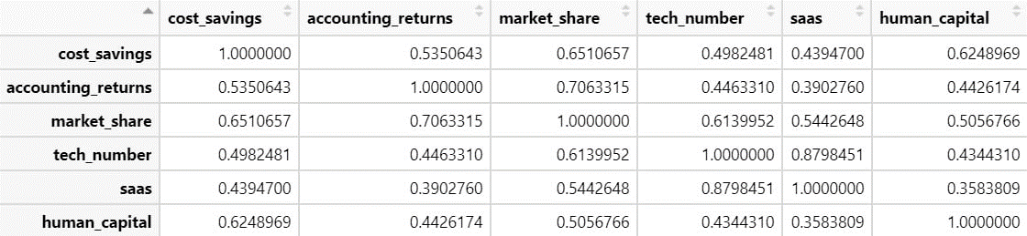

Appendix 4
Linearity assumption
Figure 1
Residuals vs. fitted values for N of technologies and cost savings
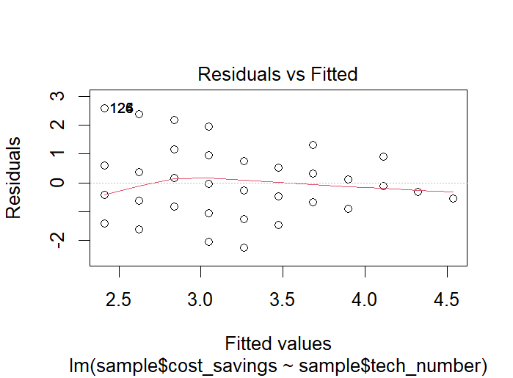
Figure 2
Residuals vs. fitted values for N of technologies and accounting returns
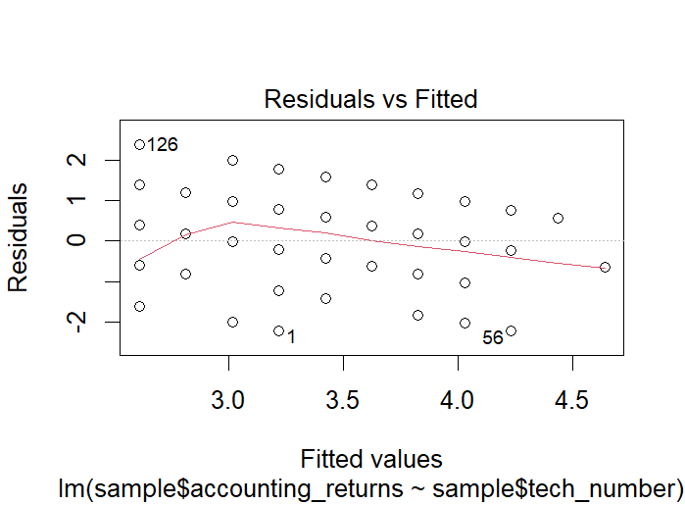
Figure 3
Residuals vs. fitted values for N of technologies and market share
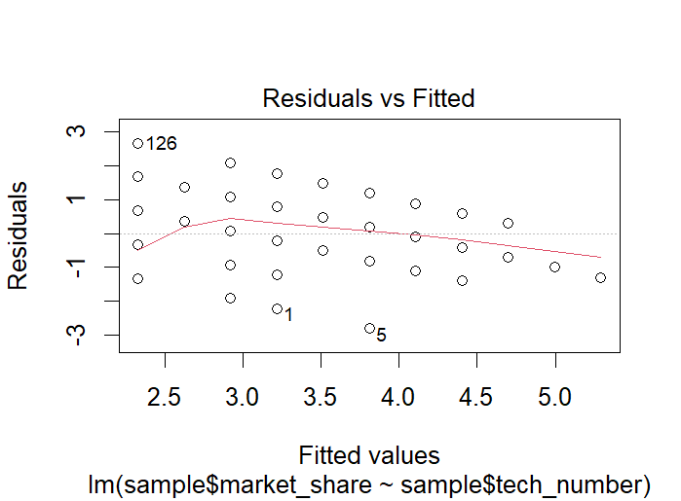
Appendix 4 (Continued)
Linearity assumption
Figure 4
Residuals vs. fitted values for IT human capital and cost savings
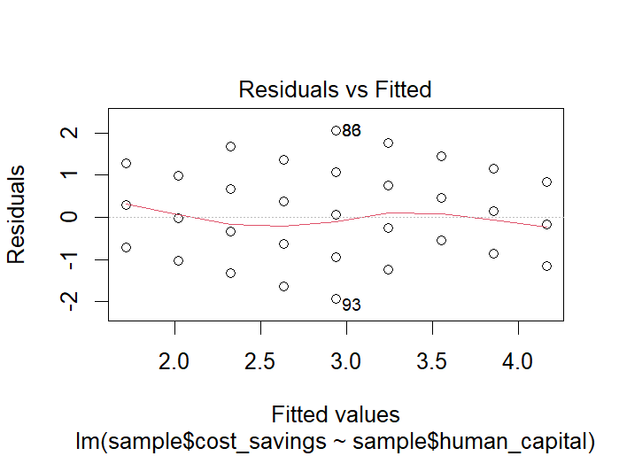
Figure 5
Residuals vs. fitted values for IT human capital and accounting returns
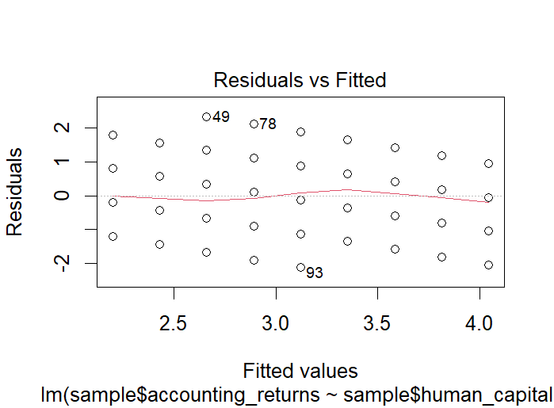
Figure 6
Residuals vs. fitted values for IT human capital and market share
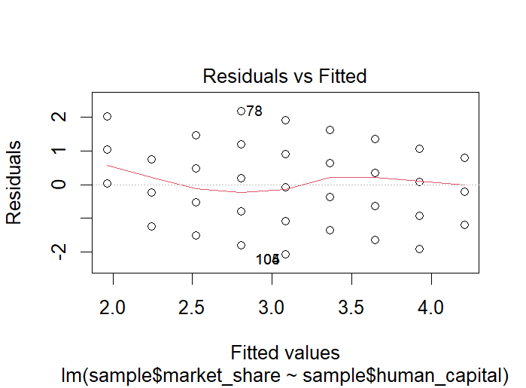

Appendix 5
Regression models 1-3

Table 1
Regression models 1-3
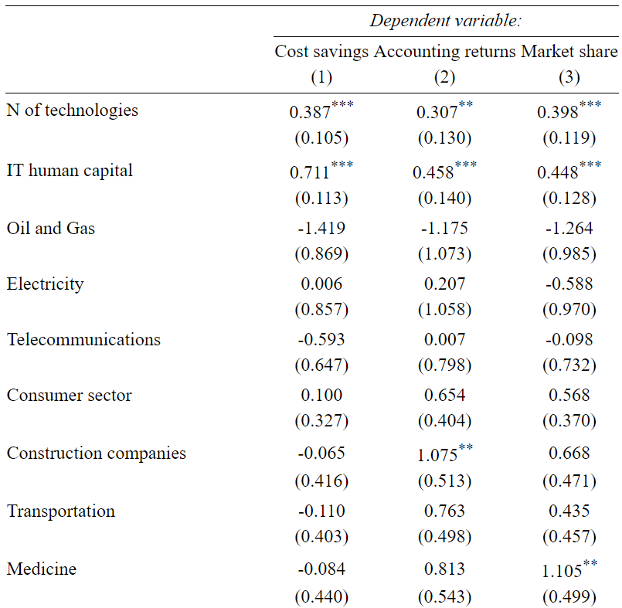
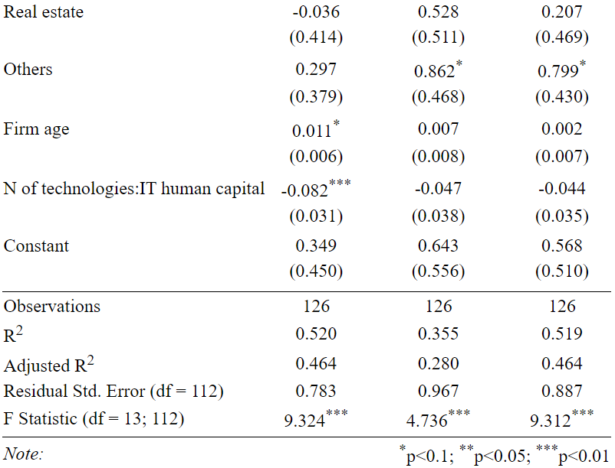

Appendix 6
Statistical tests for models 1-3
Table 1
Breusch-Pagan, Shapiro-Wilk, VIF tests for models 1-3
 | Model 1 | Model 2 | Model 3
Breusch-Pagan test
 | BP = 22.99 | BP = 12.008 | BP = 8.7942
 | df = 13 | df = 13 | df = 13
 | p-value = 0.04179 | p-value = 0.527 | p-value = 0.7883
Shapiro-Wilk test
 | W = 0.9767 | W = 0.98406 | W = 0.98991
 | p-value = 0.0283 | p-value = 0.1461 | p-value = 0.4896
Variance inflation factor
 | N of technologies: GVIF = 14.111445, Df = 1
 | IT human capital: GVIF = 3.120442, Df = 1
 | Industry: GVIF = 1.963549, Df=9
 | Firm age: GVIF = 1.213997, Df=1
 | Interaction term: GVIF = 20.557107, Df=1

Appendix 7
Q-Q plots for models 1-3
Figure 1
Q-Q plot for model 1
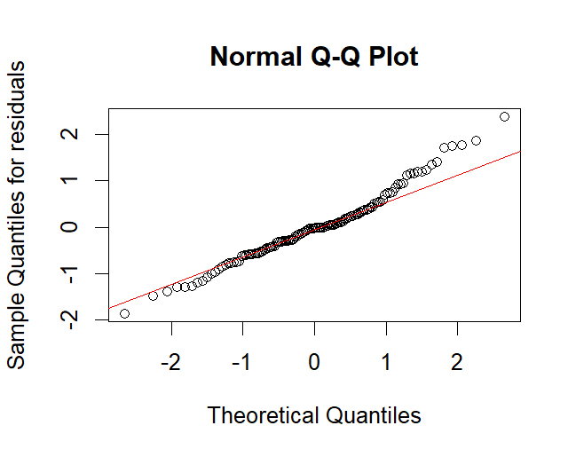
Figure 2
Q-Q plot for model 2
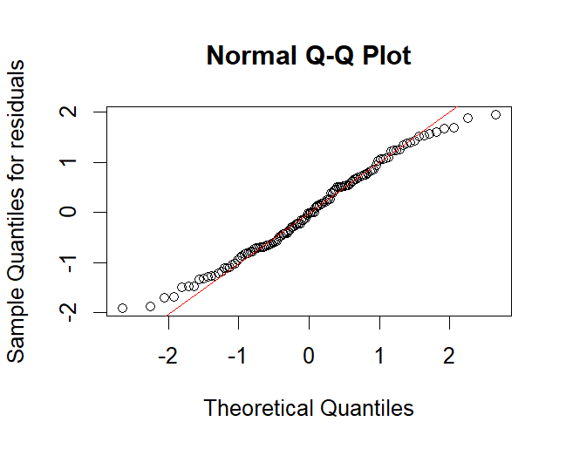

Appendix 7 (Continued)
Q-Q plots for models 1-3
Figure 3
Q-Q plot for model 3
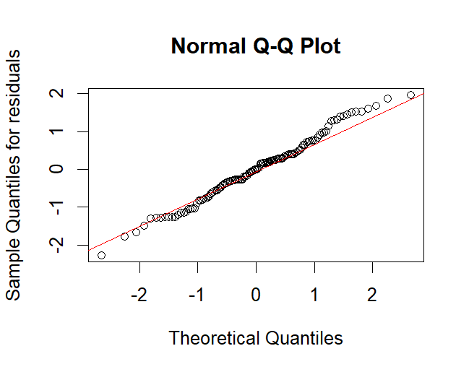

Appendix 8
Regression models 4-6

Table 1
Regression models 4-6
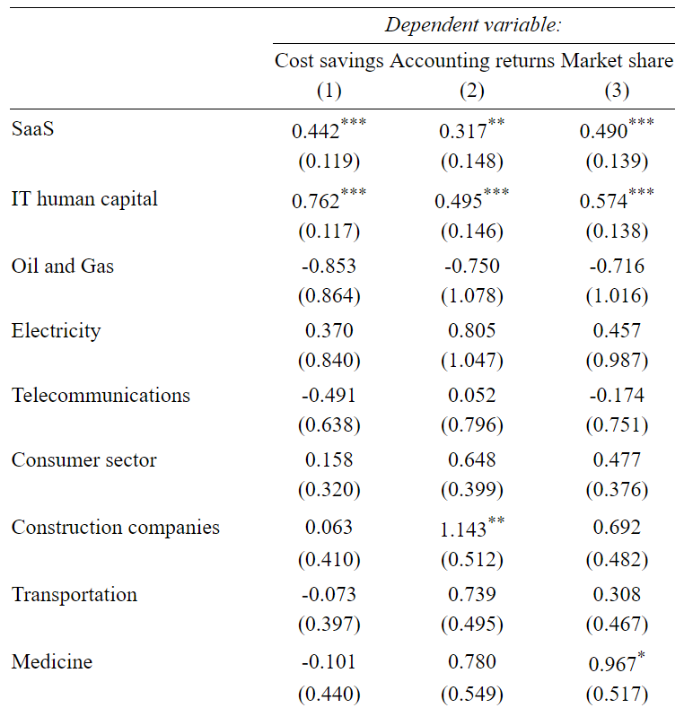
(4) (5) (6)
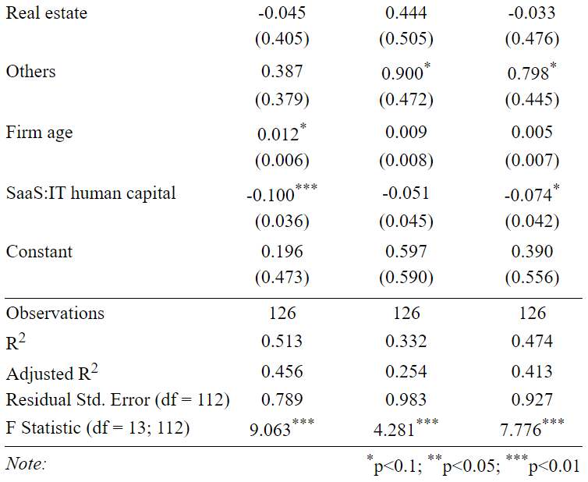

Appendix 9
Statistical tests for models 4-6
Table 1
Breusch-Pagan, Shapiro-Wilk, VIF tests for models 4-6
 | Model 4 | Model 5 | Model 6
Breusch-Pagan test
 | BP = 21.556 | BP = 11.854 | BP = 8.8818
 | df = 13 | df = 13 | df = 13
 | p-value = 0.06263 | p-value = 0.5397 | p-value = 0.7818
Shapiro-Wilk test
 | W = 0.98178 | W = 0.98421 | W = 0.98808
 | p-value = 0.08792 | p-value = 0.1511 | p-value = 0.3442
Variance inflation factor
 | N of technologies: GVIF = 10.636946, Df = 1
 | IT human capital: GVIF = 3.295627, Df = 1
 | Industry: GVIF = 1.719989, Df=9
 | Firm age: GVIF = 1.213362, Df=1
 | Interaction term: GVIF = 15.661008, Df=1

Appendix 10
Q-Q plots for models 4-6
Figure 1
Q-Q plot for model 4
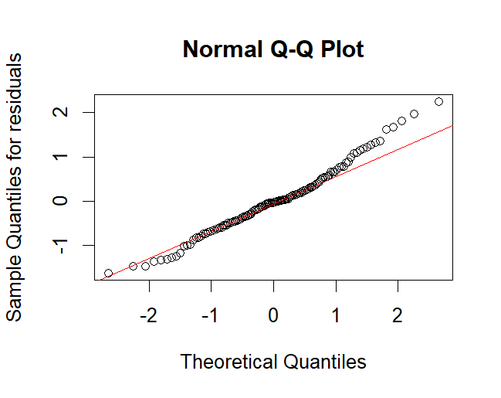
Figure 2
Q-Q plot for model 5
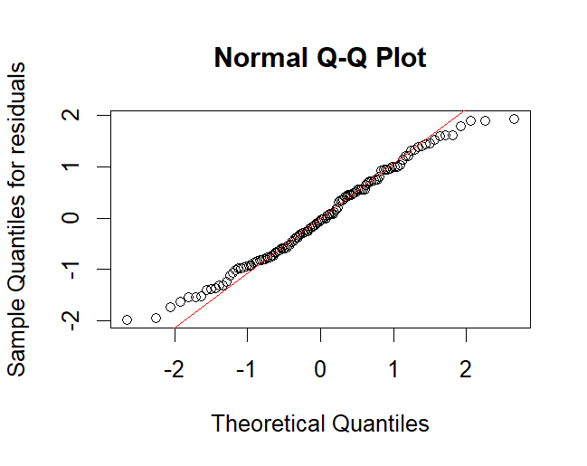

Appendix 10 (Continued)
Q-Q plots for models 4-6
Figure 3
Q-Q plot for model 6
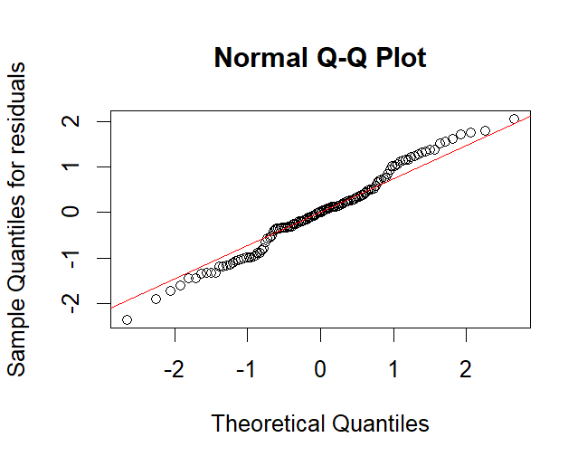

Appendix 11
Regression models 7-12
Table 1
Regression models 7-12
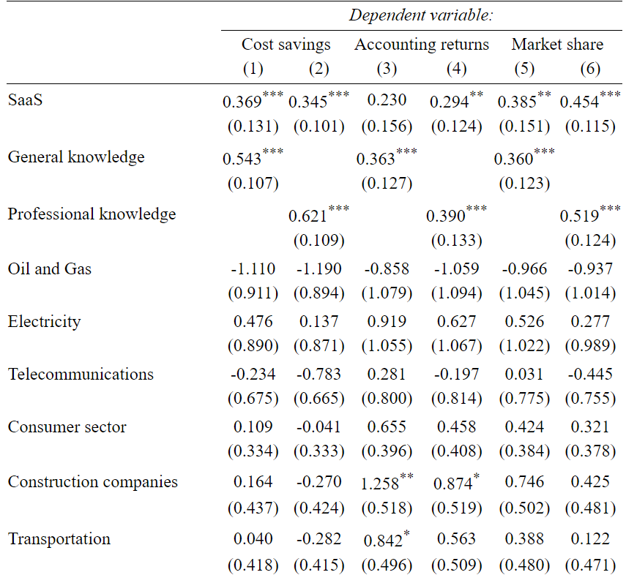
(7) (8) (9) (10) (11) (12)
